ARES – STUDENT USERS

Go to the library’s homepage and click on Course Reserve (www.gvsu.edu/library)

Sign in with your user name and password

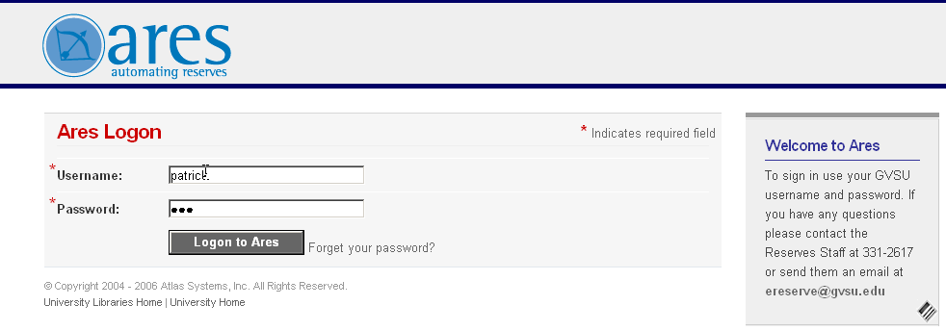

click on Login to Ares:

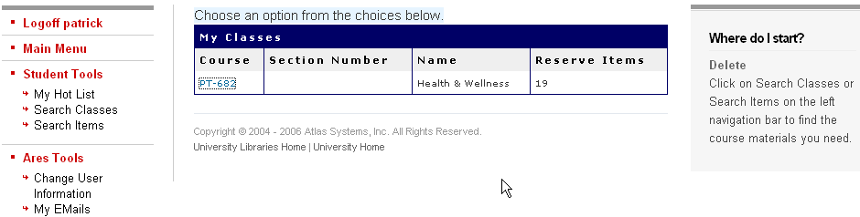

Click on Search Classes to view all classes:
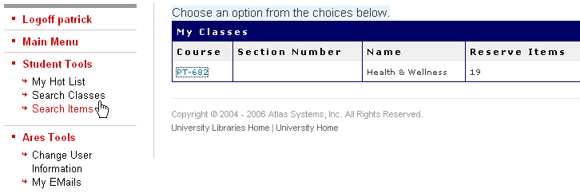

Find your class or instructor and click on Go
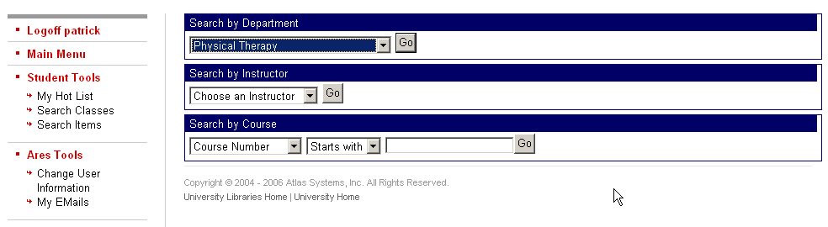

under My Classes click on the class number
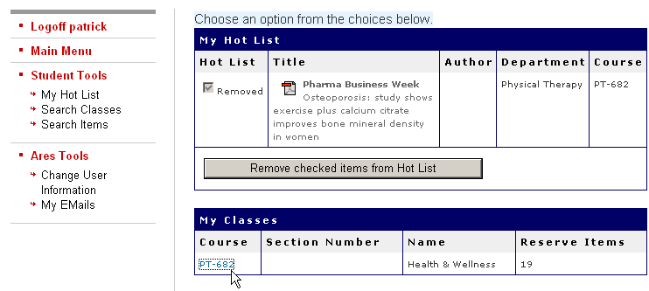

this will bring up the class information and listing:
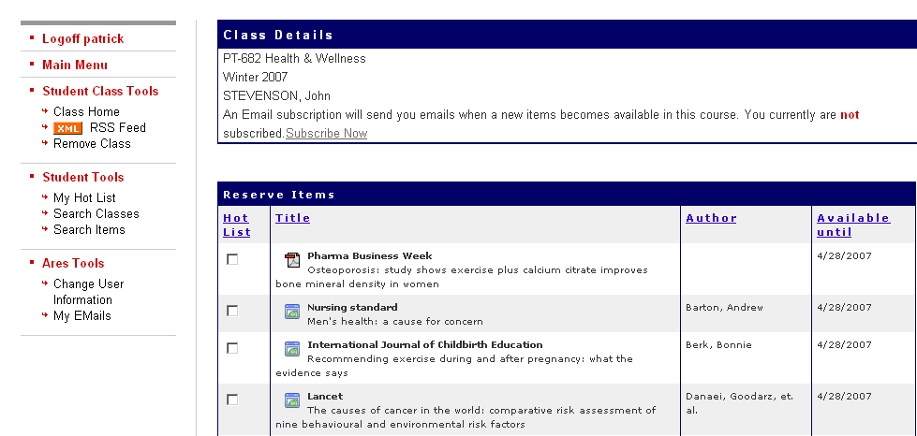
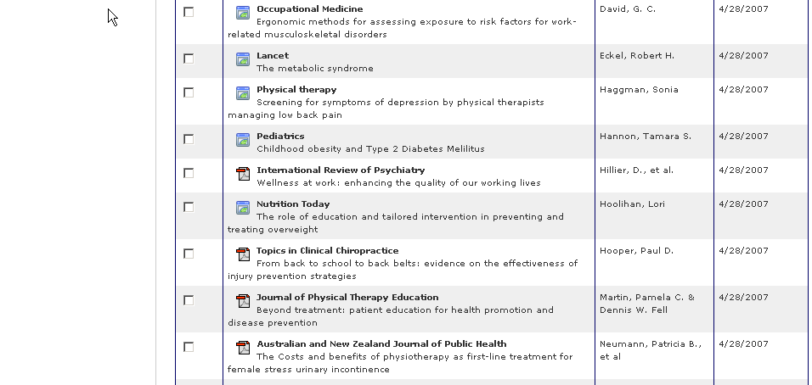

click on the icon in front of the title of the item you want
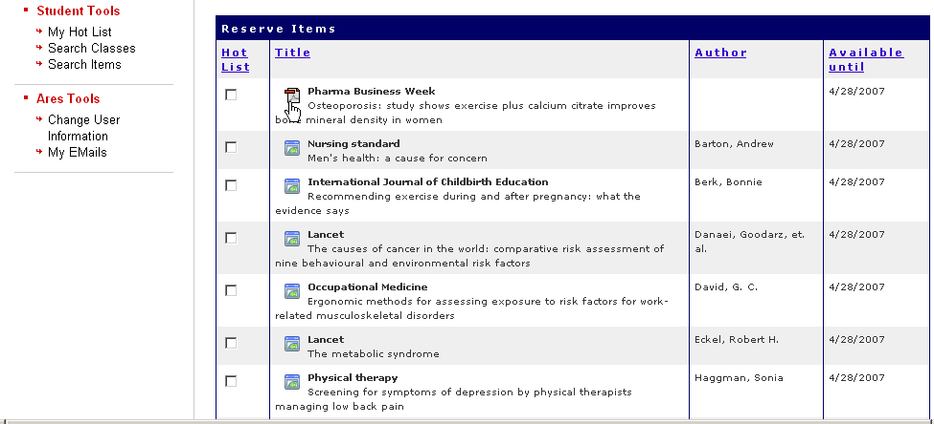

this will bring the item you want to view
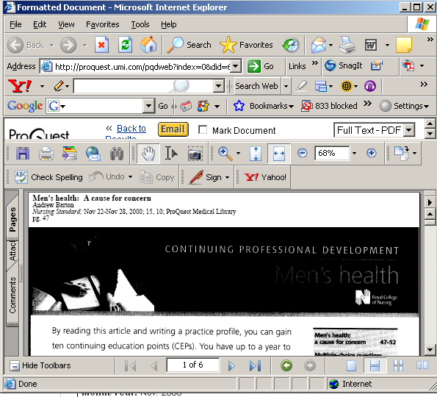

you will then be able to read, print or copy the item to a disk

once viewed it will bring up item detail
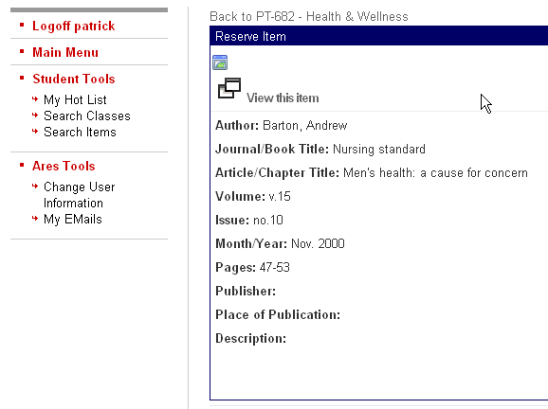
you can then go back to your previous listing or search for a new class, or a new item.

